**Operations Dashboard Instance Creation**

# Create Operational Dashboard Instance

1. Login to CP4I Platform Navigator or Platform UI. Click on **Integration Instances**.

1. Click on **Create Instances**.

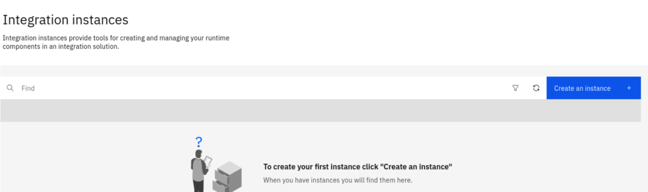

1. Select **Integration Tracing** and Click on the **Next** button.

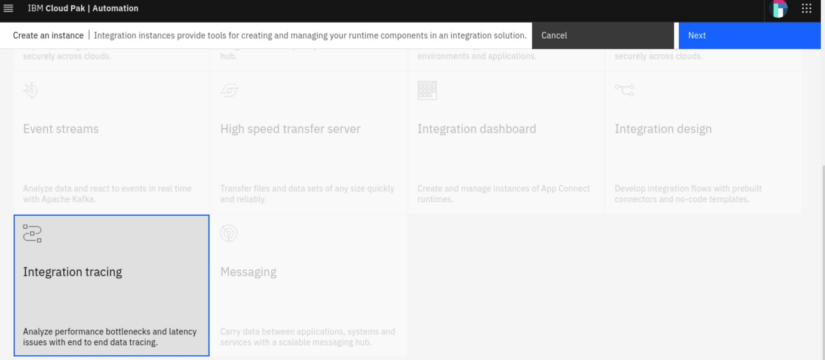

1. Click on the Sample Development Instance Type and click on the Next button.

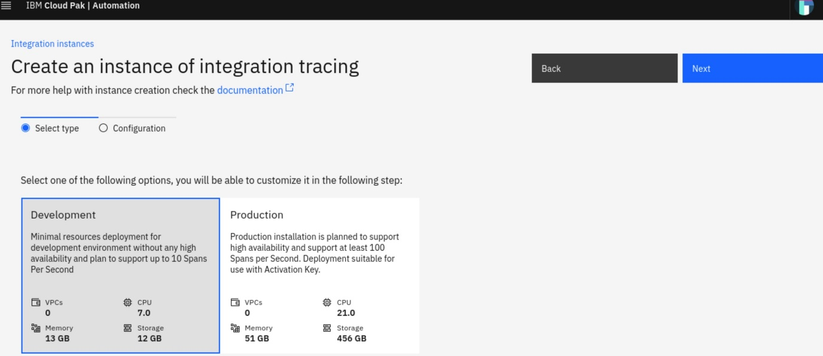

1. Provide the following configuration

**Name = cp4i-od-dev**

**Namespace = cp4i**

**License = Accept the License**

**Storage**

**Configuration Database Volume = ocs-storagecluster-cephfs**

**Shared Data Volume = ocs-storagecluster-cephfs**

**Tracing Data Volume = ocs-storagecluster-ceph-rbd**

**Version = 2022.2.1-24-lts**

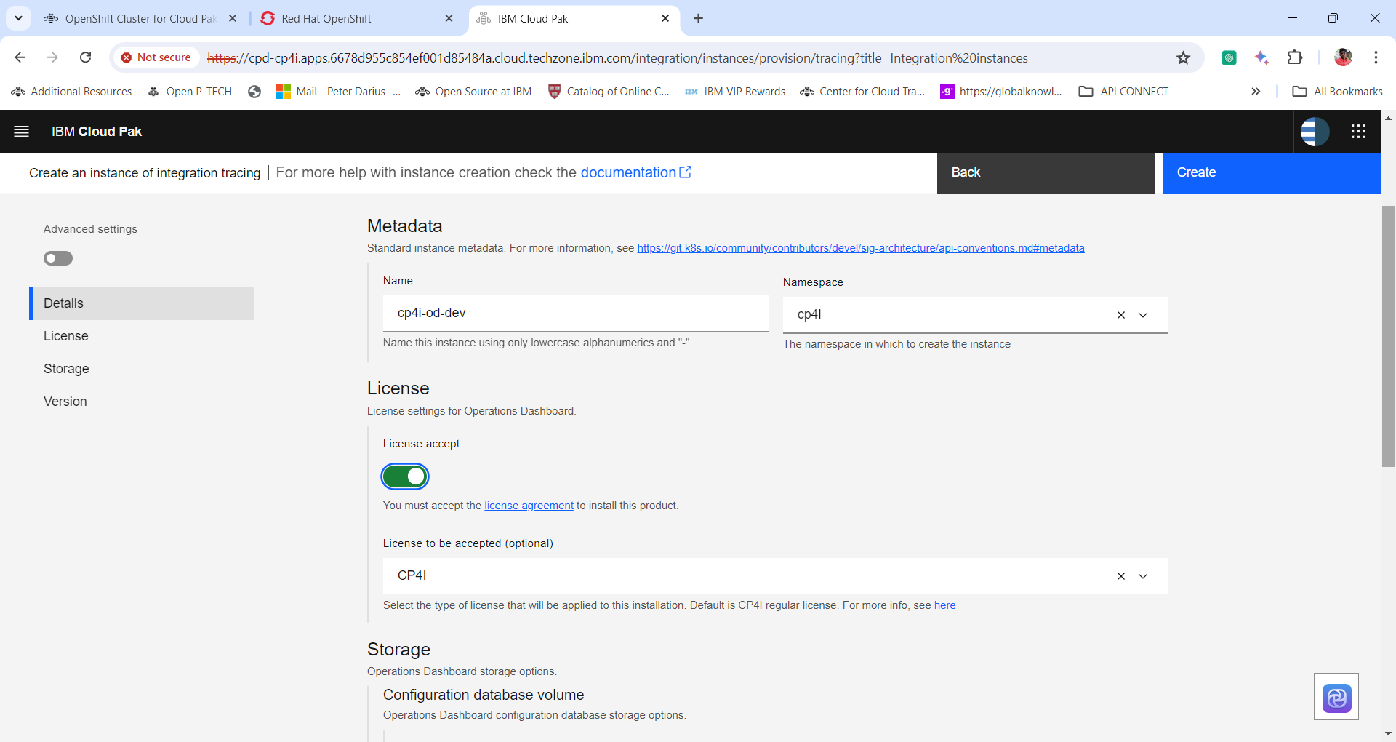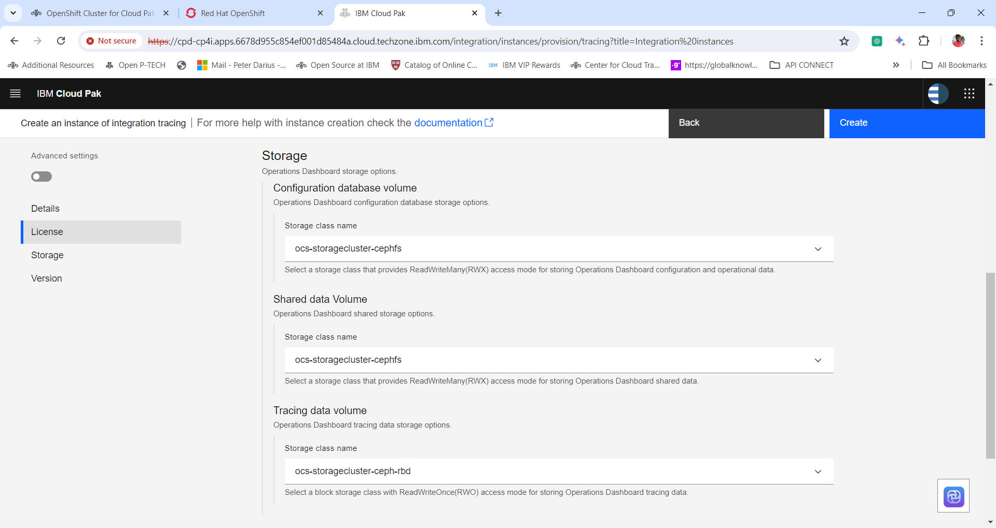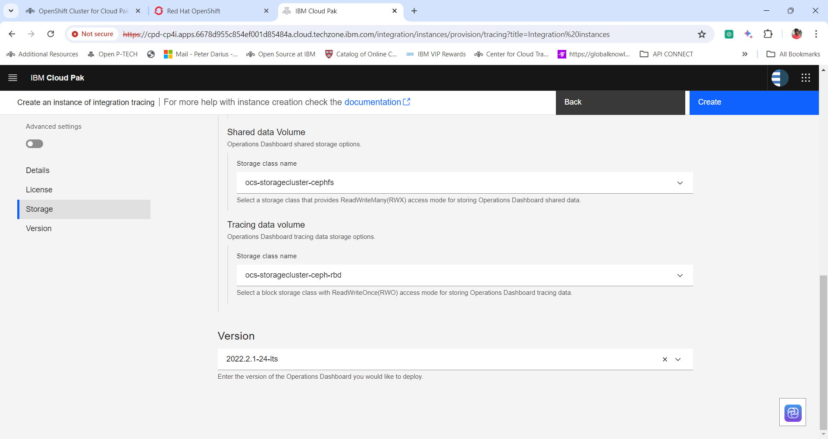

6. Wait for few minutes to spin up the instance. Once ready click on the instance name to open up the **cp4i-od-dev** console.

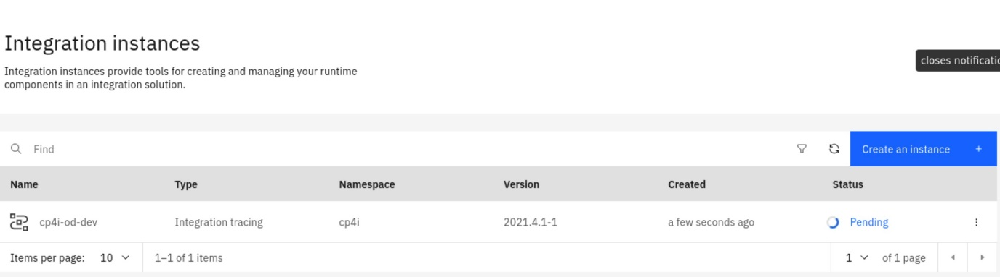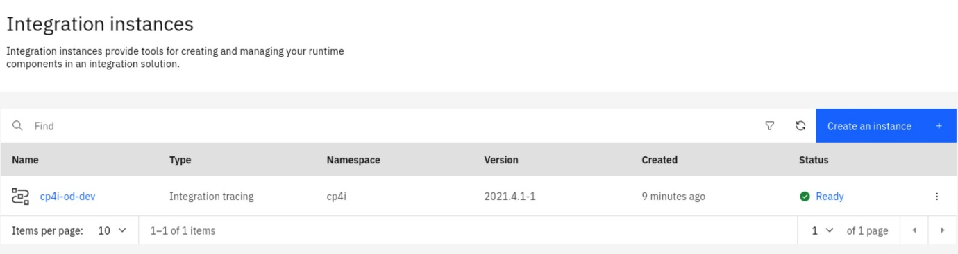

# **Test & Verify**

1. Login in to Platform Navigator & Click on Integration Tracing Option

1. Accept License

1. Click on **Overview tab** & verify if you are able to check dashboards.

Verify the Pods Created

1. Let’s check the Integration Dashboard pods created. Login into the Red Hat OpenShift Console. Expand **workloads** and click **pods**.

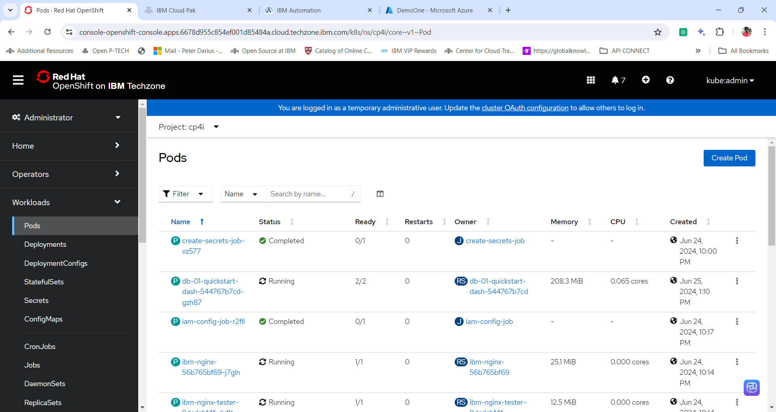

2. Change the **project Name to cp4i**. In the **search box** search operations dashboard pod by giving the operations dashboard instance name i.e **cp4i-od-dev.** And click the Operations Dashbboard pod name to view the details of the pod.

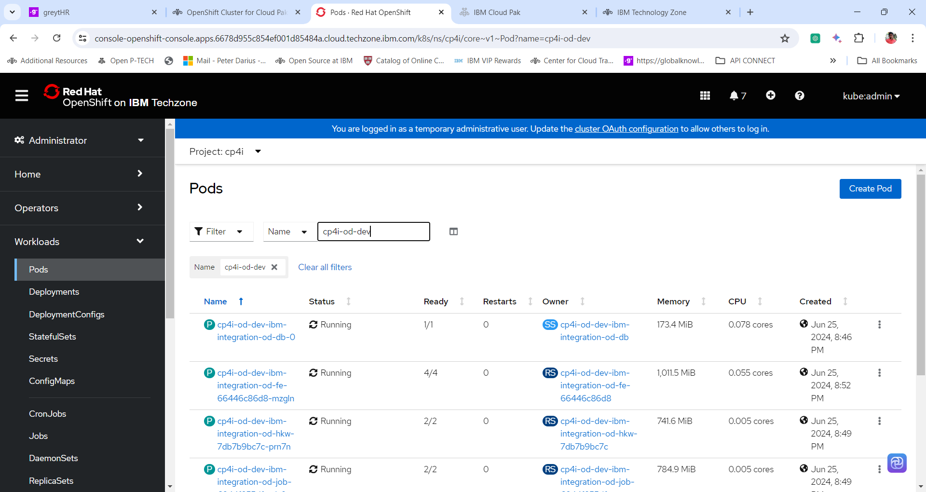

**Thanks for completing the Lab**